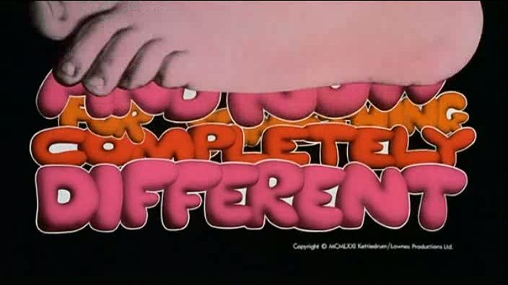
Cassy and Jamie are Carrying On Overseas on a grand world adventure for 6 months. We want to celebrate with our fabulous friends who have made Derby an awesome experience for us.
Please come to our fabulous DRESS UP leaving party in your best BRITISH COMEDY costume.
Where? Hospital Pool
When? 7pm – Saturday 19 February 2011
What to bring? Drinks
Something to burn on the BBQ (we will provide salads)
Your fabulous costume
